fall 2024
Cse-4355/5355 Electromechanical Systems and Sensors
the university of texas at arlington


lab 7 report
Submitted toward the partial completion of the requirements for CSE 4355/5355
Under the guidance of
Prof. Jason Losh
By:
Dario Ugalde, 1001268068
Joshua Martinez, 1001374818

Introduction
In this lab, we will experiment with a method used to measure weights as great as a semi-truck, and as low as a fly. For this, we used an HX711 module with a load cell amplifier. This device will be tasked with measuring a strain gauge attached to a metal bar via a Whetstone bridge circuit variant. Using our microcontroller, we will receive and process an ADC value into our appropriate values in Newtons and Grams using metal weights as our basis. Overall, this lab focuses on interfacing a weight sensor (load cell amplifier) through an ADC into our microcontroller for accurate weight and force measurements through simple conversions and calibrations.

Lab Setup and Explanation
To begin this lab, we began by connecting the HX711 device to the Vs, ground, and two pins on the TM4C, a GPO pin for the clock line and a GPI for the data line. Before moving onto the next steps, understanding the HX711 device is important. It is a 24-bit analog to digital converter made for interfacing with load cells. This cell amplifies small voltage changes into said 24-bit value from the connected strain gauge which will be explained later. It also contains various gain settings based on the number of continuous clocks it receives where we require the 128 gain from 25 clocks. Besides the microcontroller pins mentioned above, this device also has load cell wires: E+, E-, A+, and A-. Since we will be using a strain gauge, a Wheatstone bridge circuit will be necessary due to the resistance of the gauge changes based on the force applied to it. This bridge’s purpose is measuring unknown or changing resistances, making it perfect for our use case.
With this understanding, we created the Wheatstone bridge based on these pins on the HX711. 350-ohm resistors are connected between E+ to A+, E + to A-, and E- to A+. For the last connection, it will be across a strain gauge which needs to be soldered to 30 AWG bare wires and glued onto a metal bar for weighing objects. This gauge is in the shape of a rectangle with the longer side being the strain direction. This is the direction the gauge and the object it’s attaching to must both face. This allows for proper utilization of the stress analysis based on the micro changes in the strain gauge’s resistance that happens on the said object. When done correctly, the strain gauge will alter the ADC converter’s value based on the amount of weight pressing down on the bar. The mentioned wires will be connected to the Wheatstone bridge via banana jacks and toothless alligator clips completing the circuit. The following figure below helps illustrate this circuit design. Once this circuit has been completed utilizing the HX711 device through our code is the next step.

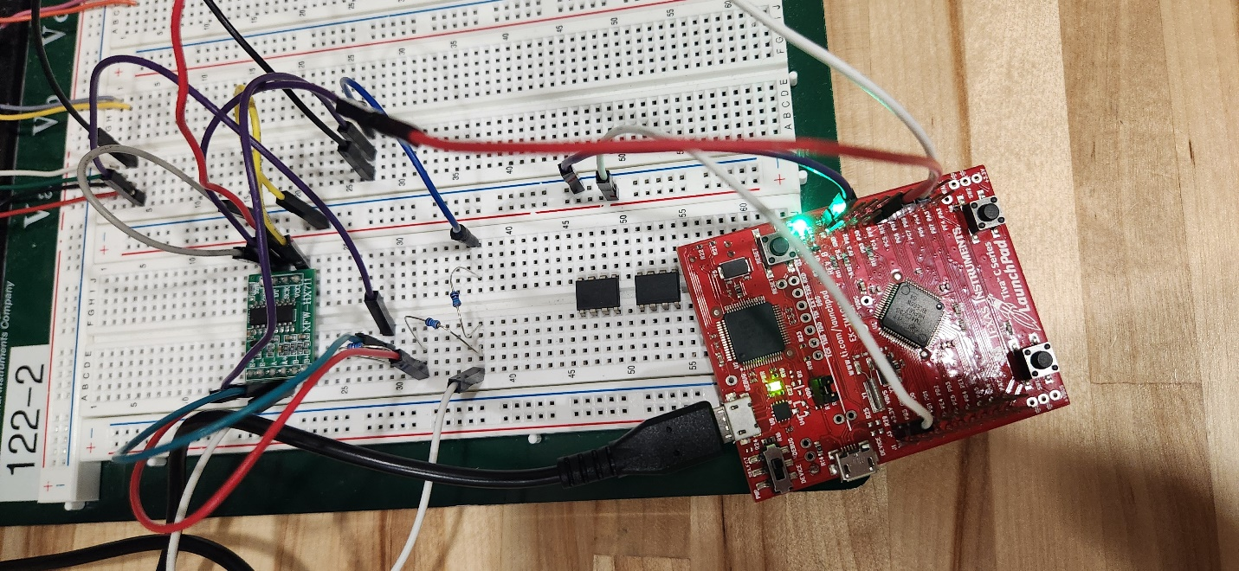

Figure 1: Circuit Design of the HX711, TM4C, and the Wheatstone Bridge

HX711 Measurements
Once the initial lab circuit has been set up, we may begin operating the HX711 device to read its values based on the strain gauge. As mentioned, this device uses 24-bits value, but they are in two’s compliment. A quick conversion to unsigned binary allows for easier understanding of the ADC’s readings and for future conversions. Since this device operates on a clock and data line, a certain method is required to acquire the 24-bit value. The clock line is pulled low, and we wait for the data line to go high. Once this occurs a loop will pull the clock line high for roughly 20 microseconds. Afterwards, we add this value onto our desired value and shift to the right afterwards since the device orders the outputs using MSB. After grabbing the state of the data line, the clock line is pulled low for one second to prepare the next value. This process will occur 24 times to receive the full value, and an additional clock line cycle is necessary to set the 128-gain option for the next reading. Once the full value is grabbed, it is reverted to unsigned binary from the two’s complement with a lower limit of zero. This is the method used to read from the HX711 and set it up for the next reading.

Weight Conversions and Errors
Once readings from the HX711 were able to be taken based on the strain gauge, these values could then be used to empirically derive a formula to calculate a force applied to the aluminum block. An initial measurement is taken to provide for the zero-force point. 225g weights were used as known weights and incrementally added and measured for 4 weights. By taking the linear regression of these 5 points, a linear regression can be used to create a formula to derive the number of grams applied onto the aluminum block. For finding Force based on grams, we multiplied the derived value in grams by 0.00981 which is the force of gravity. Gravity multiplied by gram gives us our desired force value.
During the lab, we encountered issues with the strain gauge is the adc value drifting over time and being inconsistent. To alleviate this, we implemented an ‘average’ function to calibrate a value based on ten readings for a slightly consistent change from different outputs. Another issue we encountered was our value for zero grams in the empirically derived equation for finding grams was off. We alleviated this issue by subtracting/adding a value in the weight output. With these changes, we created a rough tare for the weight and began weighing our objects. The four figures below illustrate the outputs from weighting nothing, a calculator, a water bottle, and a lab weight.
Lastly, we are asked to press on the end of the beam to shorten it. While doing this, an amount of force is detected despite no weight being placed onto the beam. This error is due to the strain gauge being unable to distinguish the differences between these two directions of force. To fix this issue, an additional strain gauge or a full strain gauge bridge is required. In the case of the latter, four strain gauges properly placed onto the beam can cancel out axial compression or torsion due to them placing equal and opposite strain of opposite gauges. This method would eliminate future errors caused by compressive forces.

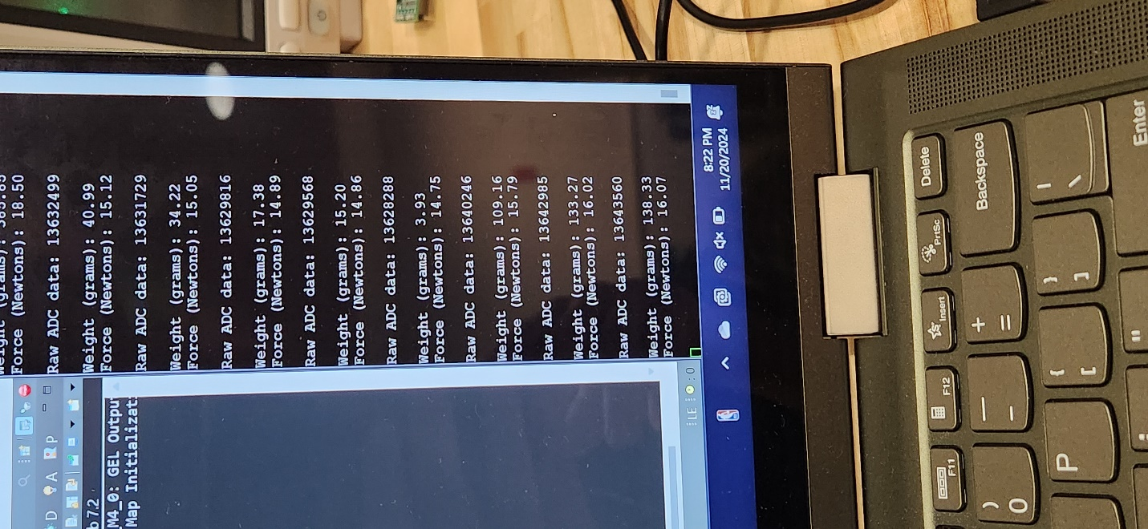
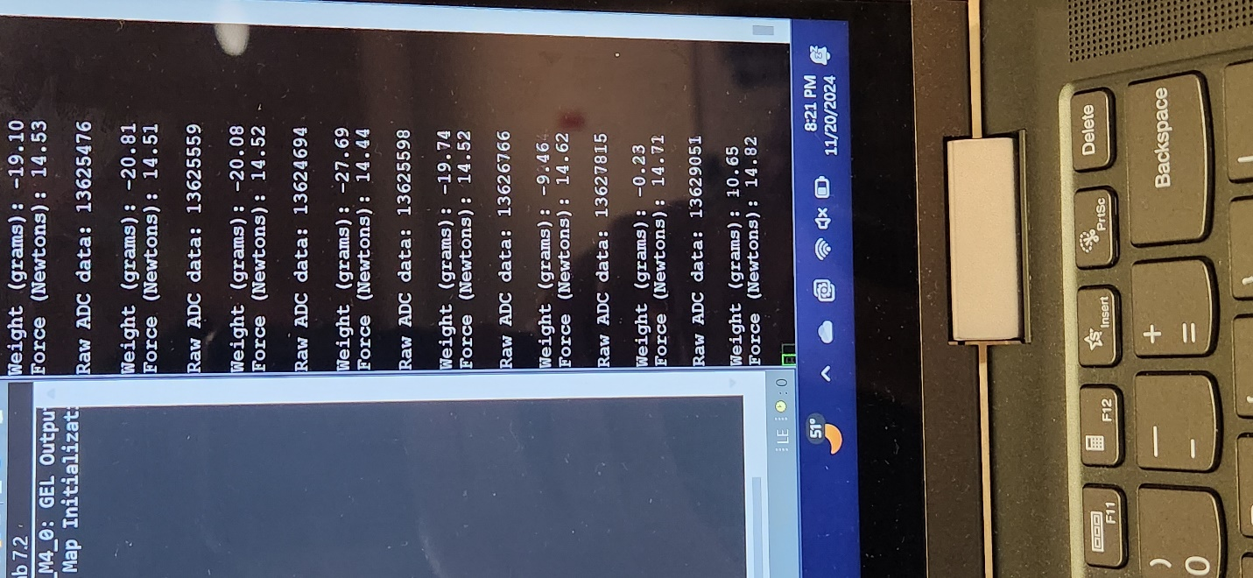
Left Figure: Scale empty w/ no weights Right Figure: Scale with Calculator

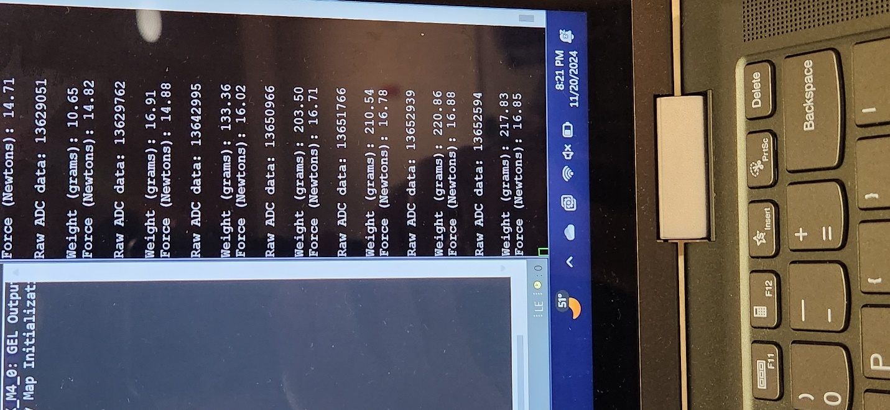
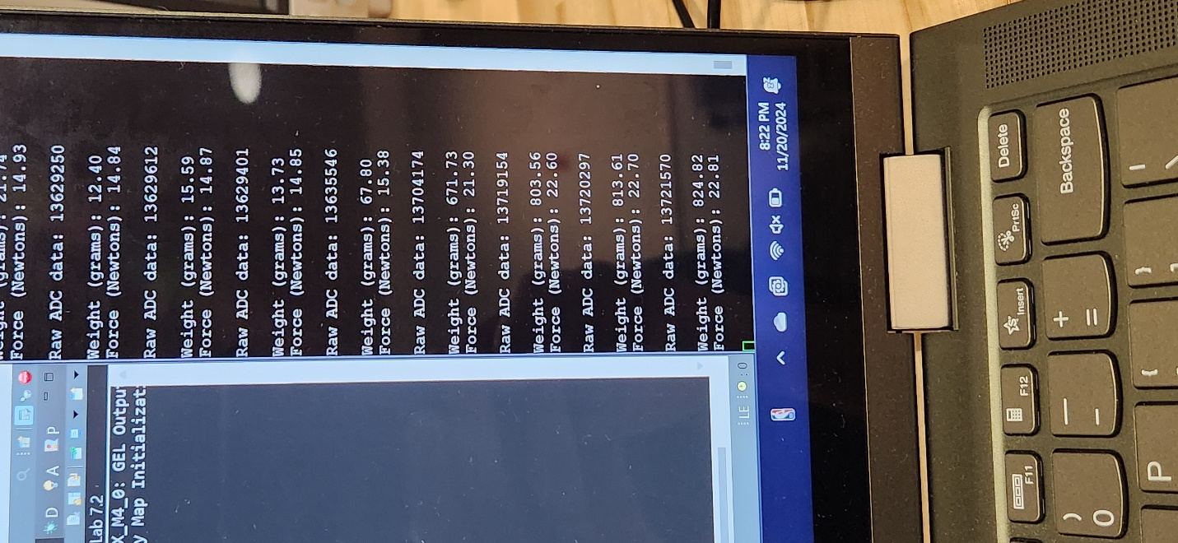
Left Figure: Scale with Water bottle (850g) Right Figure: Scale with lab weight (225g)

Conclusion – Final
This lab provided a simple application and interface into manipulating strain gauges to detect the amount of force being applied to a given surface. This example only scratches the surface of what strain gauges have to offer. In class, we discussed strain gauge systems are typically more complex where multiple strain gauges are used in each system to address impact of temperature or the application of forces in different axes.

--

Final Setup

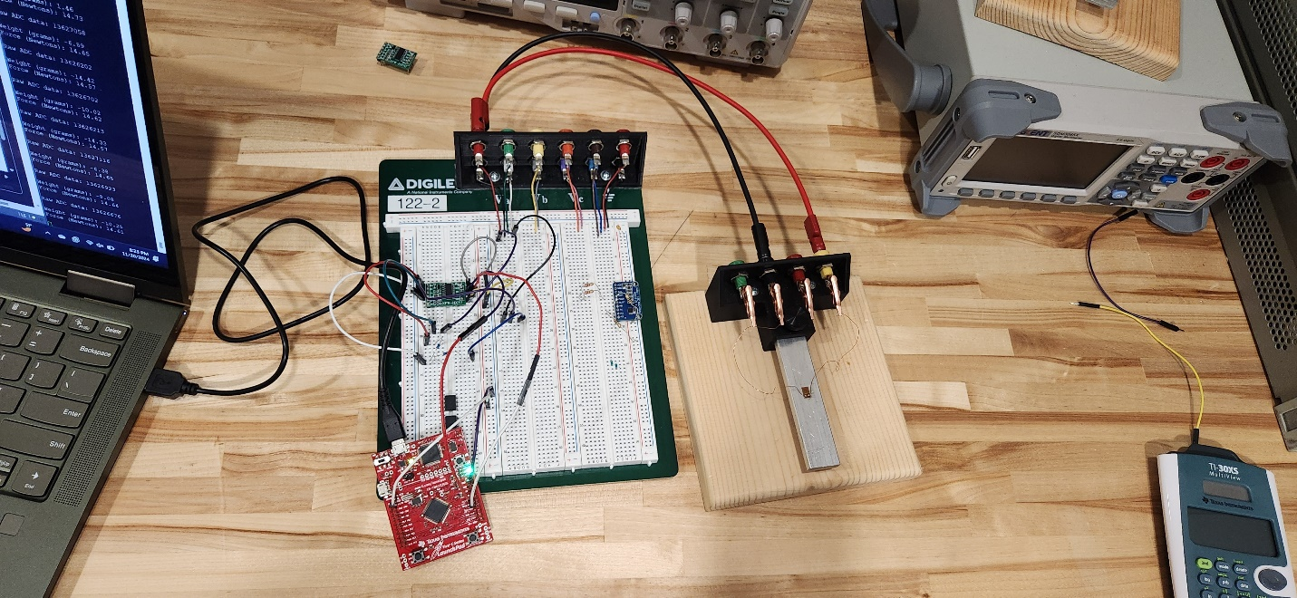

Final Setup used for lab

